Personnel & Events Dashboard – Design Document

David Owens
WGU Student ID: 011171600
D424 Software Engineering Capstone

Contents
Introduction 3
System Overview 3
Architecture Design 4
Architectural Layers 4
Data Flow 4
Architecture Diagram 4
Component Design 6
UI Components 6
ViewModels 6
Repositories 6
Data Access Objects (DAOs) 6
Database 6
Data Model 7
Entity Descriptions 7
Class Diagram 7
User Interface Design 9
Layout 9
Design Considerations 9
Dependencies and Technologies 9
Security Considerations 9
Future Enhancements 10
Conclusion 10

Introduction
The Personnel & Events Dashboard is a touchscreen-optimized Android application designed for a Coast Guard operational unit to manage personnel assignments, qualifications, and event scheduling. This document outlines the architectural design of the application and serves as a reference for developers maintaining the system.

System Overview
The Personnel & Events Dashboard provides a unified interface for staff management and scheduling through four primary functional areas:
- Shop Roster Management: Displays personnel grouped by shop with info boxes and quick reassignment capabilities
- Personnel Search & Management: Filtering, searching, and managing personnel records
- Event Calendar: Scheduling and management of events and aircraft maintenance
- Status Tracker: Tracking personnel availability and deployment status
The application is designed for large format touchscreen displays (Samsung SmartBoards) and optimizes the display of information for at-a-glance situational awareness.

Architecture Design
The application follows the MVVM (Model-View-ViewModel) architectural pattern with a clear separation of concerns across multiple layers:

Architectural Layers
- User Interface Layer (View): Jetpack Compose UI components
- ViewModel Layer: Manages UI state and business logic
- Repository Layer: Centralizes data operations and abstracting data sources
- Data Access Layer: Interfaces with the local database
- Storage Layer: Room database for persistent storage

Data Flow
- User interactions in the UI trigger actions in the ViewModels
- ViewModels request data from Repositories
- Repositories retrieve or update data through DAOs
- DAOs interact with the Room Database
- Changes in the database flow back up through the layers via Kotlin Flow objects

Architecture Diagram
This diagram illustrates the high-level components of the system and their interactions:
[See Architecture Diagram on next page]

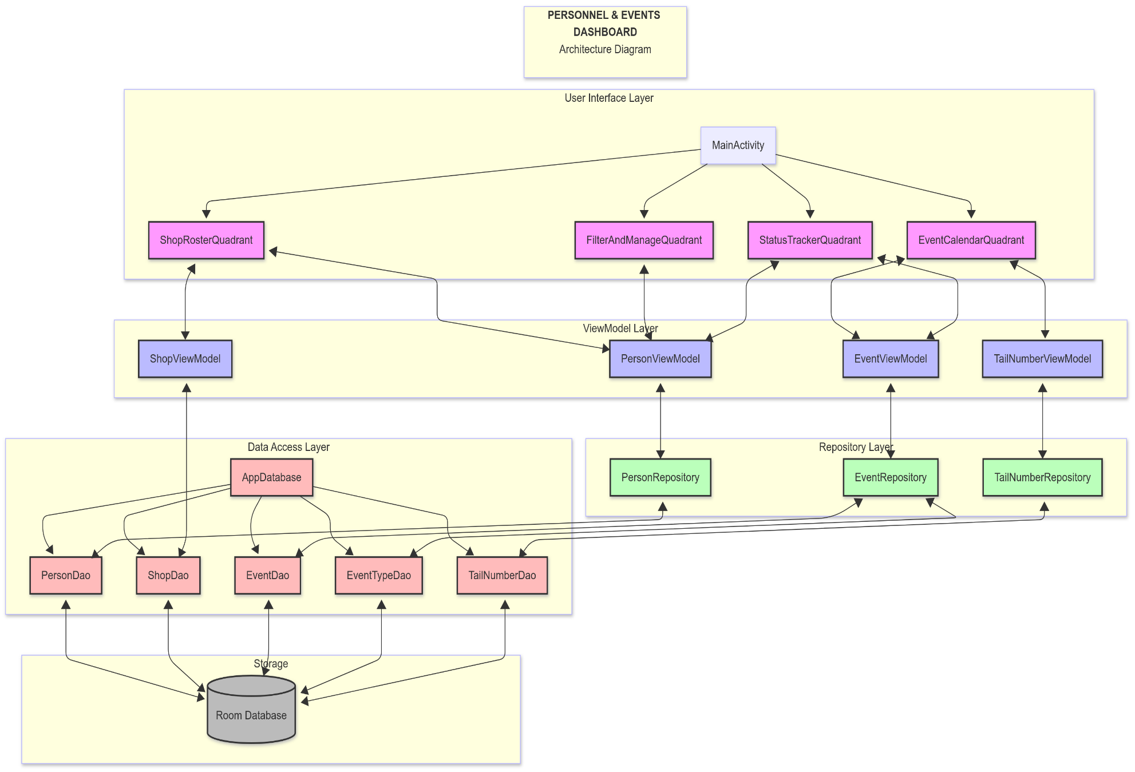
Figure 1: Architecture Diagram

Component Design

UI Components
- MainActivity: Primary container for the four quadrant layout
- ShopRosterQuadrant: Displays personnel grouped by shop with person information popup and some quick edit functionality
- FilterAndManageQuadrant: Provides filtering and personnel management functions
- EventCalendarQuadrant: Calendar interface for scheduling and managing events
- StatusTrackerQuadrant: Displays personnel availability and status
ViewModels
- PersonViewModel: Manages personnel data and operations
- ShopViewModel: Provides shop data for the UI
- EventViewModel: Manages event data and operations
- TailNumberViewModel: Provides aircraft data for the event system

Repositories
- PersonRepository: Centralizes person-related data operations
- EventRepository: Handles event data operations
- TailNumberRepository: Manages aircraft data
Data Access Objects (DAOs)
- PersonDao: Person entity database operations
- ShopDao: Shop entity database operations
- EventDao: Event entity database operations
- EventTypeDao: EventType entity database operations
- TailNumberDao: TailNumber entity database operations

Database
- AppDatabase: Room database implementation that provides access to all DAOs

Data Model
The application uses the following data entities:

Entity Descriptions
- Person: Represents personnel with attributes like name, rank, qualifications
- Shop: Represents departments or teams that personnel belong to
- Event: Scheduled events like deployments, maintenance, or training
- EventType: Categories of events with associated styling
- TailNumber: Aircraft identifiers used in scheduling

Class Diagram
This diagram illustrates the relationships between the various classes in the system:
[See Class Diagram on next page]
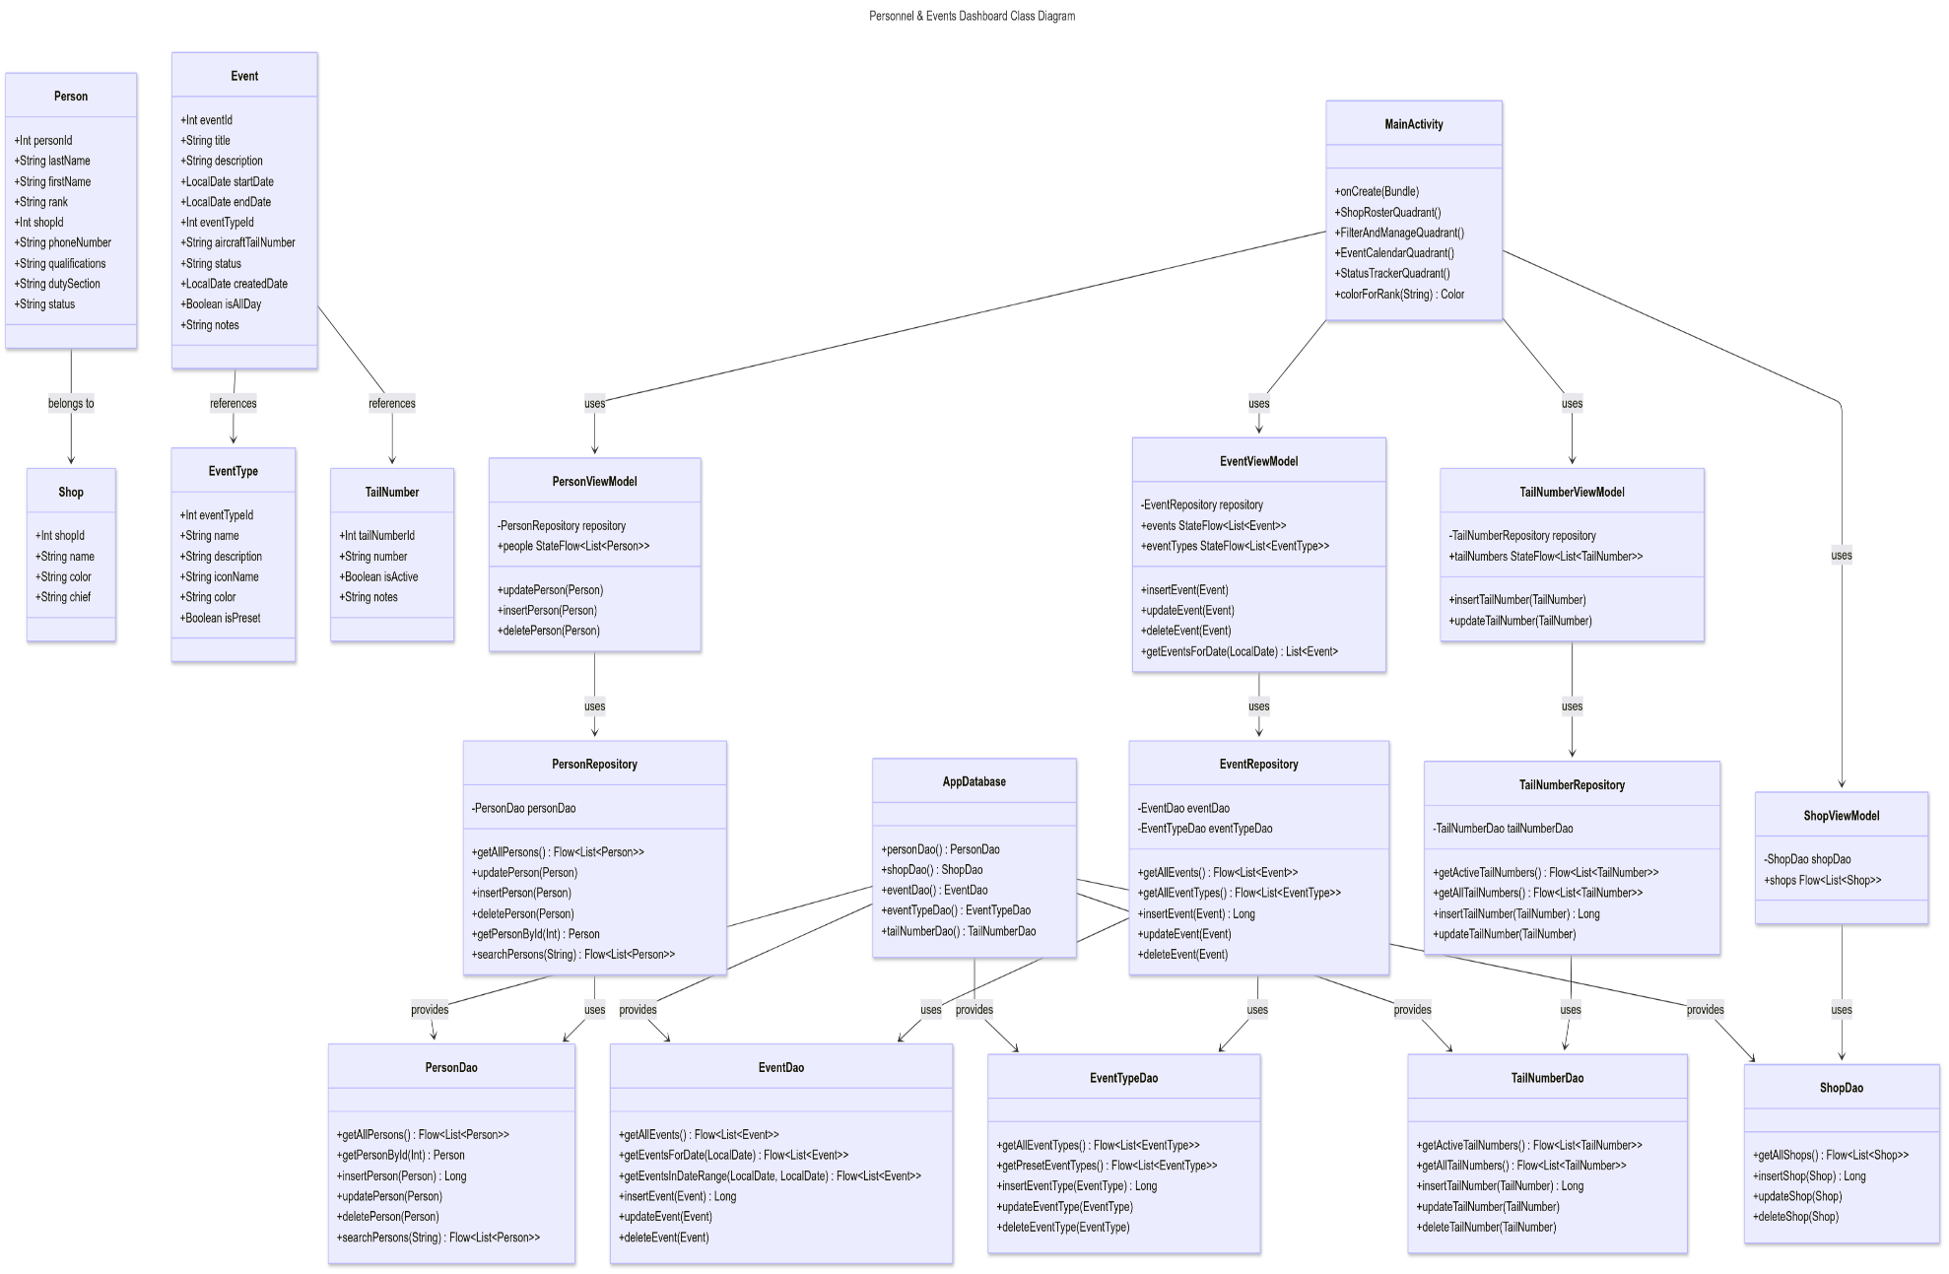
Figure 2: Class Diagram

User Interface Design
The user interface is divided into four quadrants, each focused on a specific aspect of personnel and event management:

Layout
- Upper Left: Shop Roster Quadrant
- Lower Left: Filter and Manage Quadrant
- Upper Right: Event Calendar Quadrant
- Lower Right: Status Tracker Quadrant

Design Considerations
- Touch-optimized for SmartBoard interaction
- Large UI elements for visibility on a wall-mounted display
- Color-coding for rank and status visualization
- Minimized text input in favor of selection and drag-and-drop operations

Dependencies and Technologies
- Kotlin: Primary programming language
- Jetpack Compose: UI toolkit
- Room: Database persistence library
- Coroutines and Flow: Asynchronous programming
- Android ViewModel: UI state management
- Android TV: Optimizations for large format displays

Security Considerations
- Data is stored locally on the device
- No network connectivity required for basic operation
- Future enhancements may include user authentication if network features are added
Future Enhancements
- Cloud synchronization for multi-device deployment
- Reporting and analytics features
- Integration with other Coast Guard systems
- Automated notifications for critical events

Conclusion
The Personnel & Events Dashboard is designed with a clean, layered architecture that separates concerns and enables maintainability. The MVVM pattern ensures that UI components remain decoupled from the business logic, while the Repository pattern provides a clean abstraction over the data sources.

